Longfellow Elementary School

Family Handbook

2024-2025



***A California Distinguished School***

# 3800 Olive Avenue

**Long Beach, CA 90807**

**(562) 595-0308**

**FAX (562) 424-3991**

**Click Here for our website:** [**Longfellow**](https://longfellow.lbschools.net/)

***Longfellow Elementary School Family Handbook***

***2024-2025***

***Table of Contents***

***School Holidays and Important Dates***

***District Minimum Days 2***

***Daily Schedule 3***

***Absences***

***Students Early Pick Up***

***Breakfast/Lunch 4***

***Protocol of dropping of Lunches or Other Items***

***Change of Address, Phone Number or Emergency Information***

***Medication at School***

***School Parties - Refreshments***

***Behavior Expectations/District Discipline Code 5***

***Classroom Adjustments***

***Homework***

***Library Program***

***Obtaining Student Records***

***Achievement Reports / Conferences***

***Lost and Found / Labeling Personal Items 6***

***Accident Insurance***

***PTA & VIPS***

***Field Trip Protocol***

***Inclement Weather Procedures 7***

***Hot Weather Schedule and Procedures***

***Bicycle/Scooters Rules & Safety***

***Crossing Guard 8***

***Playground Safety and Supervision***

***Care of School Property 9***

***Walking Map 10***

***Sexual Harassment – Students***

***Involvement in Drugs or Alcohol***

***In Possession of Weapons or Look-Alikes***

***School Emergency Plan***

***Longfellow Elementary School Statement Prohibiting Bullying 11***

***Letter from the Principal 12***

***Kids With Character Program***

***How Does Valet Drop Off Works?***

***After School Pick Up Procedures 13-14***

***Students Kept After School***

***Tobacco Free Schools***

***Use of Office Telephone***

***Cell Phone use /Texting Policy***

***Uniform Policy and Dress Code 15-16***

***Green Team Recycling program 17***

**LONGFELLOW ELEMENTARY**

**Holidays and Important Dates**

**Principal ~ Mr.** [Samuel Platis](mailto:splatis@lbschools.net)

**Counselor ~ Mrs.** [Grace Reyes](mailto:greyes@lbschools.net)

**Office Supervisor ~ Mrs.** [Maria Valdes](mailto:mvaldes@lbschools.net)

**Office Assistant B/L Spanish ~ Mrs.** [Miriam Gonzalez](mailto:mgonzalez8@lbschools.net)

**Nurse ~ Ms.** [Linda DIEP](mailto:ddiep@lbschools.net) **Plant Supervisor ~ Mr.** [Vaurice Scott](mailto:vscott@lbschools.net)

**Office Hours:** 7:30 a.m. – 4:00 p.m.

**School Holidays:**

First Day of School August 27 (minimum day)

[Labor Day](https://drive.google.com/file/d/1ih1JG7TmUicD15zlAE_gfi_tDJfP2jBI/view?usp=drive_link) September 2

Pupil Free Day, No School November 1

[Veterans Day](https://drive.google.com/file/d/1G8yY0JNIKCxB2TNvJgylvh3MPGho0v0o/view?usp=drive_link) November 11

[Thanksgiving Recess](https://drive.google.com/file/d/1RW_eEpdI4wuGDh604cLZeC90VRGiRiFE/view?usp=drive_link) November 28 - 29

[Winter Break](https://drive.google.com/file/d/1jWWAr4TBl3H3oTAnGL57kGZ2gh32LRDX/view?usp=drive_link) December 23 - January 3 (minimum day Dec. 20)

[Martin Luther King Day](https://drive.google.com/file/d/198YXiXyPvgLVV-gLd_D9C6HMQ1c6d8Hz/view?usp=drive_link) January 20

[Lincoln’s Birthday](https://drive.google.com/file/d/1sW8pDQQBp6pCnPWa3nZgnhxCK2mHswFo/view?usp=drive_link) February 10

[Washington’s Birthday](https://drive.google.com/file/d/1LLRtJkrXn_U1r7v5GwM95Q4AxZTGtXZO/view?usp=drive_link) February 17

[Admission Day/Spring Break](https://drive.google.com/file/d/1x03IxN4QgX15CI5KmC2CvJQr_4khQV1U/view?usp=drive_link) April 14 - 18

[Memorial Day](https://drive.google.com/file/d/1gaHiJ9jfmrtng7sjuO5fatddGMPxdduF/view?usp=drive_link) May 26

[Juneteenth](https://drive.google.com/file/d/1LkJ1CNK0VrCyUAK5v-pWzrVHu99MKB4A/view?usp=sharing) June 19

**Important Dates/Minimum Days:**

Back to School Night…………….…….September 17 (District minimum day)

Parent/Teacher Conference……….……November 4 – November 12 (District minimum day)

Winter Break …………………………. December 20 (District minimum day)

District Open House………………....... May 20 (District minimum day)

Parent Conference (as needed)………....April 1-2 (District minimum day)

Last day of School……………….……..June 12 (District minimum day)

**DISTRICT MINIMUM DAYS**

There are days set aside by the Board of Education for teacher preparation, Back to School Night, Open House, the last and first days of school, conferences and program organization. The **dismissal** on these minimum days is **1:00**. Dates are noted in the beginning of the handbook. However, reminders will be sent electronically in advance so that you may plan accordingly.

**Playground supervision** is provided for grades TK-5 from **1:00 – 3:00** on these days. ***If students are picked up late more than three (3) times in a semester, students may lose the privilege to stay after-school. Students found to have broken playground rules or disruptive behavior three times will lose the privilege to stay after school.***

Longfellow Bell Schedule

Daily Schedule for 2024-2025

|  | **TK/Kinder** | **1st** | **2nd** | **3rd** | **4th** | **5th** |
| --- | --- | --- | --- | --- | --- | --- |
| **Breakfast** | 7:30-7:50 | 7:30-7:50 | 7:30-7:50 | 7:30-7:50 | 7:30-7:50 | 7:30-7:50 |
| **Start Time** | 8:00 | 8:00 | 8:00 | 8:00 | 8:00 | 8:00 |
| **AM**  **Recess** | Group 1 8:30-9:00  Group 2 9:00-9:30  Group 3 9:35-10:05  Group 4 10:10-10:40 | 9:20-9:35 | 9:20-9:35 | 9:20-9:35 | 10:00-10:15 | 9:40-9:55 |
| **Lunch** | Group 1 10:40-11:20  Group 2 11:05-11:45  Group 3 11:40-12:20  Group 4 11:50 - 12:30 | 11:00-11:40 | 11:15-11:55 | 11:30-12:10 | 12:00-12:40 | 12:10-12:50 |
| **PM**  **Recess** |  | **1:20-1:35**  (no Thurs/Min) | **1:20-1:35**  (no Thurs/Min) | **1:20-1:35**  (no Thurs/Min) | --------------- | -------------- |
| **Dismissal** | 2:00 | 2:05 | 2:05 | 2:05 | 2:10 | 2:10 |
| **Thursday**  **Dismissal** | 1:30 | 1:30 | 1:30 | 1:30 | 1:30 | 1:30 |
| **District**  **Min. Day** | 1:00 | 1:00 | 1:00 | 1:00 | 1:00 | 1:00 |

**ABSENCES**

We urge you NOT to keep your child out of school for any reason except illness. Please plan family vacations around the school calendar. **If your child is out for any reason, you must send a written verification to the office, email** [**mgonzalez8@lbschools.net**](mailto:mgonzalez8@lbschools.net) **or fill out our** [**Google Form**](https://forms.gle/gQVKHh9qdheVD8SCA) **on our Longfellow website. The absence note must include your child’s *legal first and last name****,* **date(s) and reason for absence within 5 school days of your child’s absence and your signature. If other than the parent/legal guardian writes the note, the name and relationship to the child must be included. An absence due to illness/injury, etc., of more than 3 days will require a doctor’s release to return to school.**

Regular on-time attendance is most important for success at school Pursuant to Education Code 48260: Any student who is absent from school without a valid excuse for 3 or more days in one school year, or tardy or absent (removed early) for more than any 30-minute period during the school day without a valid excuse on three occasions in one school year, or any combination thereof, is a **truant** and shall be reported to the attendance supervisor or to the superintendent of the school district. Absence codes / EXC - Excused / Ill- Illness / TDY- Tardy / Unv- Unverified Absence / Unx- Unexcused absence / Ltu-Unx late 30+ / Ltx-Exc LLate 30+.

**School begins promptly at 8:00 a.m.** The welcome bell will ring at **7:55** to allow students time to gather belongings and line up. Students are expected to be at their classroom directly following the **8:00** bell. ***Students arriving to class after the 8:00 bell must report to the office*** for a Tardy or Late Slip. Parents/guardians of students that are habitually tardy will be required to meet with the Counselor or Principal and will be referred to Attendance Services.

**EARLY PICK UP STUDENTS**

**Early pick up** of students during the school day is discouraged and will be recorded as an **Early Out** on their attendance. However, if you need a student released early please follow these procedures:

**1)** Caregiver comes directly to the office with valid identification to request the student

**2)** Upon showing your identification the student will be called from class to report to the office (*at no time should a parent/guardian go directly to a classroom*). Students will be called until their caregiver is present in the office.

Should you need ***someone other than yourself*** to pick up your child early from school, you will need to ensure that they are listed in [**ParentVue**](https://ca-lbusd-psv.edupoint.com/PXP2_Login_Parent.aspx?regenerateSessionId=True) as an emergency contact. **Identification is required for anyone picking up a child from school. There are no exceptions.** *Parents/guardians: please be aware that anyone listed as an emergency contact in your ParentVue account with proper ID may pick up a child early from school without notification from you.* If you have a doctor, dentist or court note please fill out our [**Google Form**](https://forms.gle/gQVKHh9qdheVD8SCA) to upload the note.

Once your child is at school, he/she is not to leave campus or return home without permission from the office. If your child does arrive home without notification from the school office, please call us immediately. This LBUSD policy has been adopted for your child’s safety and to protect him/her from being taken from school by anyone except parents, guardians, or persons that you have authorized. Thank you for understanding our need to keep our students safe.

**BREAKFAST / LUNCH**

* Children may eat in the cafeteria or on the lunch benches, as directed by the Coachies.
* Free breakfast and lunch for all students this year
* Children going off campus for lunch must be signed out through the office by the parent or guardian and signed back in upon return. This will be considered an unexcused early out. *Students will not be released to anyone other than parent/guardian without written notification to the office on the day in question.*
* Daily menus: <https://www.lbschools.net/departments/nutrition-services/menus-nutrient-information>

**Breakfast:**

Breakfast is served from **7:30 to 7:50 a.m.** To avoid being marked tardy **students need to be in line by** **7:50 a.m.** in order to be served, finish breakfast and be ready to be in class at 8:00 a.m. All student meals are free.

**Lunch Applications:**

A new application is required each year. Please complete the application for your child/children even if you think you may not qualify. <https://longbeach.rocketscanapps.com> Additional funding for schools is based on the percentage of free/reduced price lunches.

**Protocol for Dropping Off Lunches or Other Items**

**Dropping off lunches or *any* other items is highly discouraged**. Students who forget their lunch will be provided a free lunch in the cafeteria. If on a rare occasion it is necessary to drop off a child’s lunch, please make sure it coincides with your child’s lunch time. We cannot disrupt the class with phone calls or deliveries of any kind. In an emergency, if lunch is dropped off at the office, the office will make every effort to notify your child at their break when possible, but it is not guaranteed. Homework will be placed in the teacher’s mailbox for pick up later in the day. **Other items cannot be left in the office or delivered to the classrooms for students.**

**CHANGE OF ADDRESS, PHONE NUMBER or EMERGENCY INFORMATION**

**Each Year, you should take a moment to review and update your student information including emergency contacts in** [**ParentVue**](https://ca-lbusd-psv.edupoint.com/PXP2_Login_Parent.aspx?regenerateSessionId=True) **.**

Please report any change of address immediately to the office. Address and phone number changes (home, work and/or cell) must be changed by the parent/guardian on your [**ParentVue**](https://ca-lbusd-psv.edupoint.com/PXP2_Login_Parent.aspx?regenerateSessionId=True). A change of address will require **two** forms of proof of residency for the new address. It is critical to keep our files current with accurate information. If you plan to be out of town, please inform the office (with signed authorization) of the person(s) who will be responsible for your child in your absence.

**It is the law**. We are required to have current emergency contact information on file for every student. **Please make sure that we have your most current work, home, & cell phone numbers** and those of at least **2** adults (other than parent/guardian) locally that we can call in an emergency, if you are not available. All persons on the Emergency/Enrollment list must be at least 18 years of age. All changes or additions should be done through your ParentVue account.

**Leaving Early** Although not required by law, it would be safest for your child, and beneficial to the teacher and office, to send a note with your child stating that your child will leave early, when, why and with whom. Only then will we know that you, the parent/guardian, is aware that your child left school early and will not be on campus.

If a note is not sent, the office will call you for verification and approval. *Please be aware that anyone on your emergency card may pick up a child early at any time with proper ID.*

**MEDICATION AT SCHOOL**

We cannot administer medication of any kind to your child at school unless a district [Medication at School Form](https://resources.finalsite.net/images/v1656863372/lbusdk12caus/ldbgidw2sfofdpxc7yn9/MedicationatSchool-ParentsRequestEN.pdf) completed by your doctor is on file in our office. This policy applies to prescription and non-prescription medications. There are no exceptions.

**PARTIES AT SCHOOL ~ REFRESHMENTS**

Elementary schools follow the district policy of not having more than two room parties a year (the day before the winter break and the last day of school). Although parents/guardians sometimes generously offer to send home-cooked goods, the LBUSD policy does not permit us to accept them. Unless prepared in class, all foods consumed in class must be store purchased.

Individual birthday parties for children **cannot** be held at school. Similarly cupcakes, cakes, or other refreshments or balloons shall not be brought to school for a child’s birthday, or any other occasion. Children may not distribute personal invitations to a party except after school hours. Please do not ask us to make exceptions.

**BEHAVIOR EXPECTATIONS/DISTRICT DISCIPLINE CODE**

School regulations are kept to a minimum and are in accordance with district and state educational code policies. The principal, counselor, assistant principal, and teachers review this ([TK/K](https://docs.google.com/presentation/d/1yIsYKdL9LOcvxJgffSg7nyAsaLXa79HRM-xSeV5A_IY/edit?usp=sharing), [1-5](https://docs.google.com/presentation/d/1JgV722Px5z8olwXrrN0yrEX3wr_ABXMtqS9-AouBuEs/edit?usp=sharing)) presentation regularly throughout the school year, in order to ensure that all students know the behavior that is expected at school. Behavior expectations are made in the interest of pupil safety and welfare, individually and collectively in order to promote an appropriate learning environment. Information can be found in the LBUSD’s [GUIDELINES FOR PARENTS AND STUDENTS](https://www.lbschools.net/departments/equity-engagement-partnerships/parent-engagement/parent-guidelines). Should you have questions regarding any of these policies, please call the office. Teachers may set reasonable additional behavior expectations individually. Please view the notices and board policies for parents/guardians and students required by the district: [Title IX Parent Notification](https://drive.google.com/file/d/1r-upt774Ncfa3EuX8hnWGBq8PaXpnMPb/view?usp=sharing), [UCP Annual Notification](https://drive.google.com/file/d/1kAOrf-C_kSS1eNGP8WCFISwKziLJVD0m/view?usp=sharing), [Safe Place Poster](https://drive.google.com/file/d/134O_uiWeCilmd6hjW7K9KRx2nvssB_dA/view?usp=sharing) and [TK-5: Reporting Sexual Harassment Poster](https://drive.google.com/file/d/135MHE3rpHeJSi1Dwx93B-6m4uQ12MPzQ/view?usp=sharing).

**CLASSROOM ADJUSTMENTS**

Despite the care given to class placement before the start of school, enrollment and transfers of students into and out of our school may require moving students’ classrooms in order to balance class sizes. We appreciate your efforts to help your child understand these changes.

**HOMEWORK**

The LBUSD Homework Plan can be found in the [GUIDELINES FOR PARENTS AND STUDENTS](https://www.lbschools.net/departments/equity-engagement-partnerships/parent-engagement/parent-guidelines) on page 46 under “Homework Plan Involves Three Crucial Partners.” Special arrangements need to be made if a student misses school work because of an absence. We urge you to see to it that your child completes all assigned homework.

**LIBRARY PROGRAM**

Our school library is an important part of our curriculum. Its purpose is to supplement and to enrich the classroom reading program. Children are scheduled for regular periods in the library for a variety of activities, including instruction on library skills and reading choices. Books are checked out for one week. Students are responsible for taking care of and returning books. There are no fines for overdue books, but **students will be required to pay for lost and/or damaged books**. Achievement Reports can be held and the fine will follow them into the next school year.

**OBTAINING STUDENT RECORDS (COPIES)**

You may obtain and print all student file records through ParentVue. Records in ParentVue include attendance, Achievement Reports, IEP information, demographics, proof of enrollment, etc.

**ACHIEVEMENT REPORTS AND CONFERENCES**

Achievement Reports are provided to all students twice a year – once in **January, and again in June** through [**ParentVue**](https://ca-lbusd-psv.edupoint.com/PXP2_Login_Parent.aspx?regenerateSessionId=True). Parent/guardian conferences for the first report period will be held in **November**. This will allow teachers and parents/guardians to have the opportunity to discuss student progress before the Achievement Report is posted. As-needed parent/guardian conferences will be held in **April.** The last Achievement Report will be posted at the end of the school year. Additional parent/guardian conferences are welcomed any time that you have a concern about your child. You need only to notify your child’s teacher to arrange a conference time to the mutual satisfaction of all concerned.

Parents/guardians are also welcome to observe in their child’s class; however, prior arrangement with the teacher and administrator, by phone or a note in advance is necessary. Observations are up to 30 minutes to avoid disruption to the remainder of the students. Observers are accompanied by a school administrator.

**LOST AND FOUND / LABELING PERSONAL ITEMS**

All sweaters, coats, jackets, lunch boxes, backpacks, and other personal belongings, **should be clearly labeled** **with first and last names**. This prevents mix-ups in ownership and theft; furthermore, hundreds of nearly new items are left unclaimed. These could be returned if proper identification is labeled clearly.

We encourage you to check in the office, and at the coat rack located outside the cafeteria, after school. **If lost items are not claimed within 4-6 weeks, we have made arrangements to have the clothing donated to charitable organizations. This is due to the large amount of clothing that we are unable to store.**

**ACCIDENT INSURANCE**

It is a fact of life that accidents will happen. Parents/guardians may want to consider purchasing the school-time protection or 24-hour protection insurance plan. More information [Student Injuries and Insurance](https://resources.finalsite.net/images/v1718919246/lbusdk12caus/yd3mfb8ve6fmhfnmrn2z/Student-Insurance-EN.pdf),

**PTA AND VIPS**

**PTA:**

We urge every parent/guardian and interested citizen to join and participate in the Parent Teacher Association [Longfellow PTA](https://lblongfellowpta.org/Home). Throughout the school year you will be receiving information concerning membership, meetings and special activities. Please sign up for a committee, ***we need you*!** Our PTA President is Malis Man**.**

**VIPS (Volunteers In Public Schools):**

Many parents/guardians in our school district have found this program to be both an interesting and rewarding one. Volunteers may do many things to help the children at Longfellow Elementary School. Once processed, a VIPS may ***chaperon on field trips*** with their child, read to children, work in the classroom, help in the library, etc. ***Parents/guardians who are not VIPS*** ***cannot volunteer with students, including chaperoning on field trips.*** The teachers and staff at Longfellow have always appreciated the tremendous help received from these wonderful volunteers. If you are interested in learning more about becoming a volunteer, please fill out this [VIPS form](https://docs.google.com/forms/d/e/1FAIpQLSfsR4SzWalDTr7Xrg0rnaQZFnv4eYRpTycUr3bFQFZ8se0FRg/viewform) or contact Maria Valdes before November 1st at (562) 595-0308 or email at [mvaldes@lbschools.net](mailto:mvaldes@lbschools.net) [VIPS Agreement, 2023-2024](https://docs.google.com/document/d/1yL-nyRtOijTs1dYKU_Gz7cRjNtbixdbNR8gHX0KIBdo/edit?usp=sharing)

**FIELD TRIP PROTOCOL**

Throughout the year students will participate in additional learning experiences such as off campus field trips.

Field trips are a privilege and require students to maintain good behavior in class and on campus, as well as keeping up with their school work. Some points to remember for field trip protocol are:

* All students must have a *signed permission slip* to attend a field trip.

* *Field trip attire*: unless otherwise stated, students are to be in uniform and must wear closed-toed walking shoes.

* By law, all students are offered to receive *either a boxed lunch from the cafeteria* or they may choose to *bring a lunch* when lunch is eaten at the venue. Should a boxed lunch from the cafeteria be needed, notification to the teacher is required on the provided document.

* *Siblings or other children* **may not** go on a field trip. Per district policy, field trips are reserved for Longfellow

students, teachers and district approved VIPS only.

* *Chaperones* are **VIPS,** volunteers chosen by the teacher, who have applied at Longfellow and have been processed by the district’s VIPS office. Anyone not processed as a VIPS **will not** be allowed to attend a field trip. This is a district policy; please don’t ask us to make exceptions, district employees included.

* *Students requiring medication* to be taken on a field trip must have a Medication at School form on file & signed

by the doctor. Medication cannot be taken or administered without this document. There are no exceptions.

**INCLEMENT WEATHER PROCEDURES**

When adverse climate conditions arise (rain, severe winds, air quality, excessive heat, etc.), a rainy day schedule is called. Before and after school activities may be moved to the school auditorium and/or cafeteria. The auditorium will be open **at 7:40 a.m**. to receive students and again at the end of the school day until **3:00 p.m.** for those students not immediately picked up.

***We encourage you to have students picked up as early as possible at the end of the school day to avoid overcrowding in the cafeteria and auditorium. Pick up is in front of the school during inclement weather schedule.***

**HOT WEATHER SCHEDULE AND PROCEDURES**

On days when a temperature of 95 degrees persists for the majority of the day, hot weather precautions will be implemented.

**Physical Education**

PE will be modified on days of extreme heat. PE may be held in the morning prior to 11:15 a.m., and not after. More classes can participate at the same time and will be allowed to use the upper and lower playgrounds. Alternately, teachers may choose to teach lessons in class or shaded areas.

**All grade levels are limited to less strenuous activities.

**Recess Times**

Recesses will be limited to less strenuous games. Students at lunch recess are encouraged to avoid running, ball play or any form of strenuous activities. Alternate activities such as: board games, reading, coloring, frequent restroom & water breaks to cool off. Students may be required to remain in the auditorium for lunch recess, in situations where it is deemed a potential health risk to be in the extreme heat.

Students will have access to all supervised shaded areas at lunch recess. When available, EZ-Up shade will be placed in specific areas of the school grounds to provide additional shade. Placement of duties for playground supervision will be adjusted to cover additional shaded areas away from the main playground, at lunch recess.

**After School**

Students will go into the auditorium to watch a movie.

**Signaling a Hot Weather Day**

As a hot weather schedule will only be called on days with an ongoing temperature of 95 degrees or greater, a verbal announcement will be made for all classes to hear. Once a hot weather schedule has been called, it will remain in effect for the rest of the day.

**Bicycles/Scooters Rules and Safety**

Please go over these safety rules with your child.

*All bicycles and scooters must be parked and locked in the bike racks provided.

*All students riding bicycles and scooters to school must wear a helmet.

*Students may not ride on campus.

**\**Students caught riding in an unsafe manner or without a helmet may have their privilege to ride a bike to school revoked.***

**\*We will not be responsible for damaged, lost or stolen bicycles, scooters or skateboards.**

**Crossing Guards:**

Children must follow the Crossing Guard’s instruction when crossing the intersections. Longfellow’s crossing guard is located at Bixby Road and California Avenue. For safety, please encourage your child to cross the street where crossing guards are present. The hours are: **7:30 – 9:30 AM and 1:05 – 3:35 PM.**

**PLAYGROUND SAFETY & SUPERVISION**

With large groups of children playing together, it is necessary that some play practices are not permitted at school. These include: tumbling, karate/kick fighting, wrestling, chasing, etc. Play areas are assigned in relation to age groups. Reminders from parents/guardians to their children concerning safe play at school would be greatly appreciated. After-school supervision is a privilege. A student must maintain appropriate behavior after school.

**NOTE: Students found to have broken playground rules or disruptive behavior three times will lose the privilege to stay after school.**

**Toys of any kind, including electronic devices, fidget spinners, trading cards, etc., are not permitted.**

**\*We will not be responsible for damaged, lost or stolen items brought from home.**

Students are taught to report any injury on the playground to the adult on duty. *Please remind your child to tell the teacher or coach on the playground, or their classroom teacher, if injured or ill.*

**NO “heelys” or skates** will be permitted on the school grounds because of the possible damage to school property (Board Policy 3515.3) as well as the safety of all students.

**SUPERVISION ~** As a reminder—**children MAY NOT be on the Longfellow playground before 7:40 a.m. or after 3:00 p.m.**  The office will document and call the parents/guardians of students who come too early or remain after **3:00 p.m.** Playground supervision is for students in grades TK – 5th. TK and K will be in their smaller playground. Grades 1-5 will be on the Big Playground. Please be prompt in picking up your child. **After three late pick-ups in one semester your child may no longer be allowed to play after school.**

Children staying on the playground after school **may not leave the campus for any reason** except to go home. Students are not to leave campus and return with food purchased at local establishments. Under such circumstances, parents/guardians will be notified and the after school playground privilege may be revoked. However, if the student feels it is necessary to return to the school due to safety reasons, the student must go directly to the office.

**Walking to School:** Safety is part of each grade level’s curriculum. You can help by frequently reminding your child of the safest route to take and the safety rules to follow when walking to school. You will find “Safe Route Map” for Longfellow School on the next page. Please review this carefully with your child.

**CARE OF SCHOOL PROPERTY**

We appreciate your help in working with us to build pride in our school and community by encouraging your child to show respect for school property. Dollars spent to repair damage caused by vandalism means fewer dollars available for books. Damage caused by the reckless use and misuse of the campus also causes money to be diverted for repair. ***Parents/guardians are held financially responsible by law for the acts of their children which result in damage to school property (this includes equipment, books, materials, desks, and to the school building itself).***

You can help by reinforcing proper use of the school grounds with your child and by reporting any vandalism or damage to the school. Problems such as vandalism and other emergencies, such as fire or breaking and entering may be reported to the LBPD or district security office if the school is closed.

**The LBUSD 24-hour security number is 562-997-8101.**

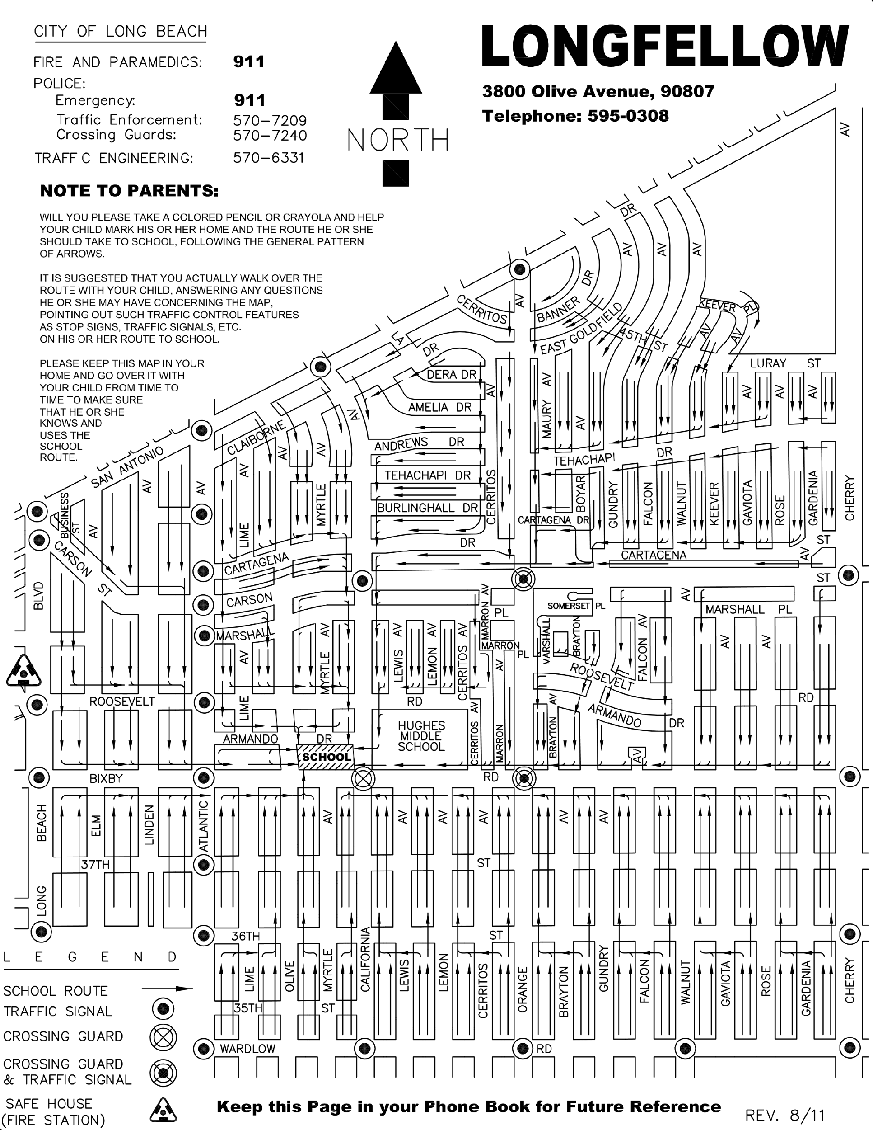

**Prohibition of Sexual Harassment – Students:**

The Long Beach Unified School District is committed to maintaining a working and learning environment that is free from sexual harassment. Sexual harassment of or by employees or students is a form of gender discrimination and is a violation of state and federal laws and a violation of this policy. The district considers sexual harassment to be a major offense, which will result in disciplinary action to the offending employee or the suspension or expulsion of the offending students. The district prohibits retaliatory behavior against anyone who files a sexual harassment complaint or any participant in the complaint investigation process. Each complaint alleging sexual harassment shall be promptly investigated in a confidential manner, respecting the privacy of all parties to the fullest extent possible.

In accordance with Board Policies 5145.7 (Sexual Harassment), 5145.9 (Hate-Motivated Behaviors), 5131.2 (Bullying Prevention), and 5142.52 (Suicide Prevention), students will review key procedures and processes to support a safe and welcoming environment. For additional information regarding these requirements, [GUIDELINES FOR PARENTS AND STUDENTS](https://www.lbschools.net/departments/equity-engagement-partnerships/parent-engagement/parent-guidelines) can consult pp. 31 <https://www.lbschools.net/about/sexual-harassment>.

**Involvement in Drugs or Alcohol at School**

It is important to caution all students regarding student involvement in drugs and alcohol at school or at any student body activity (even those off campus). This bulletin is to place students on notice that any involvement with controlled substances, including alcohol or any intoxicants, while at school, going to and from school, or while at any student body activity, will result in disciplinary action. The discipline ranges from a disciplinary transfer to another school to expulsion from the Long Beach Unified School District. This also includes instances where a student is not the owner of the substance.

**In Possession of a Weapon or Look-Alike at School**

It is important to caution all students regarding student possession of a weapon or look-alike at school or at any student body activity (even those off campus). This bulletin is to place students on notice that any possession of a weapon while at school, going to and from school, or while at any student body activity, will result in disciplinary action. The discipline ranges from a suspension to expulsion from the Long Beach Unified School District. This also includes instances where a student is not the owner of the weapon.

**SCHOOL EMERGENCY PLAN**

Longfellow has a site emergency plan which consists of the following:

* Regularly scheduled fire drills
* Earthquake drop drills
* Lockdown drills
* Full scale emergency evacuation drill

Our staff has been trained and assigned individual duties in the event of an emergency. The emergency bin is stocked with supplies such as water, first aid supplies, generators, and rescue and safety equipment.

All gates will remain locked in the event of any emergency. All students will file out to the playground and remain there until it is determined that it is safe to go back into the buildings. We will have a command center and first aid area in place on the playground.

Parents/guardians will be able to pick up their children at the Release Gate at the Bixby & California gate. Please be sure your child’s Emergency/Enrollment information is always kept up to date in ParentVue as our students will only be released to those persons on your child’s emergency card who have proper identification.

**Longfellow Elementary School Statement Prohibiting Bullying**

At Longfellow Elementary School bullying is prohibited (a) on school grounds, at a school sponsored or school-related activity, function or program whether on or off school grounds, at a school bus stop, on a school bus or other vehicle owned, leased or used by a school district or school, or through the use of technology or an electronic device owned, leased or used by a school district or school and (b) at a location, activity, function or school-related program or through the use of technology or an electronic device that is not owned, leased or used by a school district or school. Bullying shall not be tolerated and not allowed to create a hostile environment at school for the victim, infringe on the rights of the victim at school or materially and substantially disrupt the education process or the orderly operation of a school. Retaliation against a person who reports bullying, provides information during an investigation of bullying, or witnesses or has reliable information about bullying shall be prohibited**.**

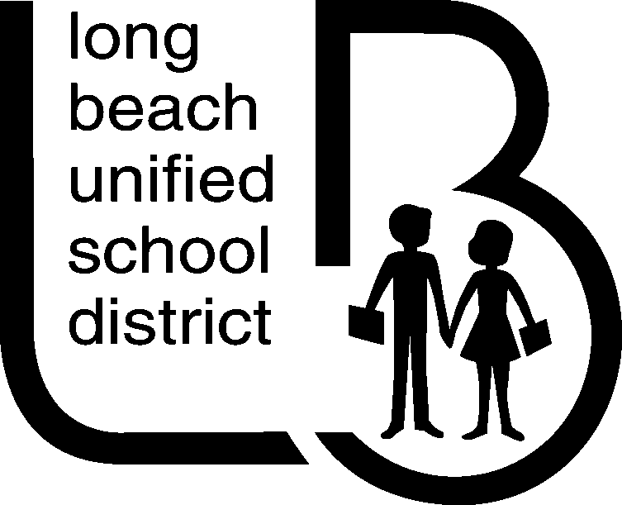

Dear Caregivers of Longfellow Students,

Should an emergency or disaster situation ever arise in our area while school is in session, we want you to be aware that the schools have made preparations to respond effectively to such situations. In fact, public schools in California are built to meet stringent construction standards and they may be safer than your own home in the event of a disaster.

Should we have a major quake or disaster during school hours, your child(ren) will be cared for at this school. Our school district has detailed disaster plans which have been formulated to respond to a major catastrophe, including earthquakes.

**Your cooperation is necessary in any emergency. Please follow these guidelines.**

1. Do not telephone the school. Telephone lines may be needed for emergency communication.
2. In the event of a serious earthquake, students will be kept at Longfellow until they are picked up by an **identified**, responsible adult who has been designated as such on the student’s Emergency Profile which is required to be completed or updated by parents/guardians at the beginning of every school year. Please be sure you consider the following criteria when you authorize another person to pick up your child from school:
   1. the person is at least 18 years of age
   2. they are usually home during the day to receive emergency calls from school
   3. they can walk to the school site if necessary
   4. they are known to your child
   5. they are both aware and able to assume this responsibility
3. Turn your radio to KFI 640 AM, KNX 1070 AM, or KFWB 980 AM for emergency announcements. If students are to be kept at school, radio stations will be notified. If electrical service is not affected, information will be relayed via the School District’s cable Channel 51. In addition, information regarding day-to-day school operations will be available by calling the LBUSD Administration Building at (562) 997-8000.
4. Impress upon your children the need for them to follow the directions of any school personnel in times of an emergency.

Students will be released only to parents/guardians and persons identified on the School District Emergency Card. During an extreme emergency, students will be released at the designated reunion gates located on Bixby Rd. & California Ave. Please instruct your child to remain at school until you or a designee arrives.

The decision to keep students at school will be based upon whether or not streets in the area are open and safe. If this occurs, radio stations will be notified. In the event that a major earthquake, where roads are impassable, takes place during the time that students are being transported, students will be kept on the bus and the driver will ask for assistance through radio contact with the school and district safety personnel.

In case of a “hazardous release event” (chemical spill) near the school area, “Lock Down” procedures will be implemented to provide in-place protection. All students and staff will clear the fields, report to their rooms, and all efforts will be made to prevent outside air from entering classrooms during the emergency. Students arriving at school during a “Lock Down” drill or event should report to the school office or to a previously designated area at the school since classrooms will be inaccessible. When the dangerous incident has subsided, an “all clear” signal will be given.

In the event of an assumed dangerous individual on campus, the “Lock Down” procedures will again be implemented with locked doors. An automated message over the loudspeaker will be sounded alerting all staff to bring children into the nearest shelter and lock the doors. When the dangerous incident has subsided, an “all clear” signal will be given.

Please discuss these matters with your immediate family. Planning ahead will help alleviate concern during an emergency.

Sincerely,

[Sam Platis](mailto:splatis@lbschools.net)

Principal

**Kids with Character Program**

The “Kids with Character” program celebrates the six Character Counts Pillars: Responsibility, Trustworthiness, Respect, Fairness, Caring, and Citizenship. Longfellow Elementary School strives to use the pillars to describe and elicit positive character traits in our students and staff. The six pillars are introduced at a school award ceremony and are celebrated through our Kids with Character Certificates and the Gold Slips that are given to students exhibiting these character traits throughout the school.

**HOW DOES VALET DROP OFF WORK?**

As a member of the Longfellow School Community we know that parking around our school is limited and that morning traffic can be congested. Currently there is a valet drop off located in 2 locations: Bixby Ave and Olive Ave. The valet system provides our families with a safe and convenient way to drop off children in the morning.

To ensure everyone's safety, please read the following *Do’s and Don’ts for Valet Drop Off*. Check the map that visually describes the following information.

**Do**

1. Have your child ready with all her/his belongings (backpack, lunch pail or any other item a student might need) to exit the car when you enter the valet area.
2. Pull into the valet lane.
3. Pull up as far forward as possible.
4. Come to a complete stop, **for your safety all drivers must maintain in the vehicle.**
5. Once your children have exited, and the vehicle’s door is closed, stay in the valet line and move with the flow of traffic until you reach the end of the valet lane.

**Don’t**

1. **Do not stop in the red, or in the crosswalk.** Please remember a red curb, driveway and crosswalk mean no stopping or dropping off.
2. Do not drop children off in the alley.
3. **Do not let children out on the driver’s side.**
4. Do not double park and allow children to exit your vehicle.

And please remember, if your child **walks** to school they must use the crosswalks. If your children ride their bikes/scooter, they must always wear their **helmet** (it’s the law) and walk their bikes/scooters once they get to Longfellow Elementary School.

**After School Pick-Up Procedures**

***Supervised play on the playground is until 3:00 only***

**QUESTIONS & ANSWERS**

* ***Where do I pick up my child after school?***

**Grades 1 – 3** ~ Bixby and Armando exits are open between **2:05 & 2:15** on Monday, Tuesday, Wednesday and Friday, between **1:25 & 1:40** every Thursday, and between **12:55 & 1:15** on District minimum days.

**~** Once gates close, please pick-up onArmando and California by **3:00,** when the playground closes.

* **Grades 4 & 5** ~ Bixby and Armando exits are open between **2:10 & 2:20** on Monday, Tuesday, Wednesday and Friday, between **1:25 & 1:40** every Thursday, and between **12:55 & 1:15** on District minimum days.
* ***Students may not stay out in front of the school awaiting pick up..***
* All students not picked up prior to the exit's closing will be swept back to the large playground near California Ave. for pick up.

~ The Bixby & California gates will be closed at **2:20** (**1:40** on Thursday and **1:15** on District minimum days)

~ Students will be picked up at the Armando & California gate. Coachies will locate students as parents/guardians arrive for pick up. Parents/guardians may not loiter. There is a designated area for adults picking up students to wait near California & Armando.

***For Safety and supervision, we are a closed campus. Due to a busy office, we cannot take calls in the office to locate or call for students from the playground after school. Please go to the Armando and California exit to pick-up your child.***

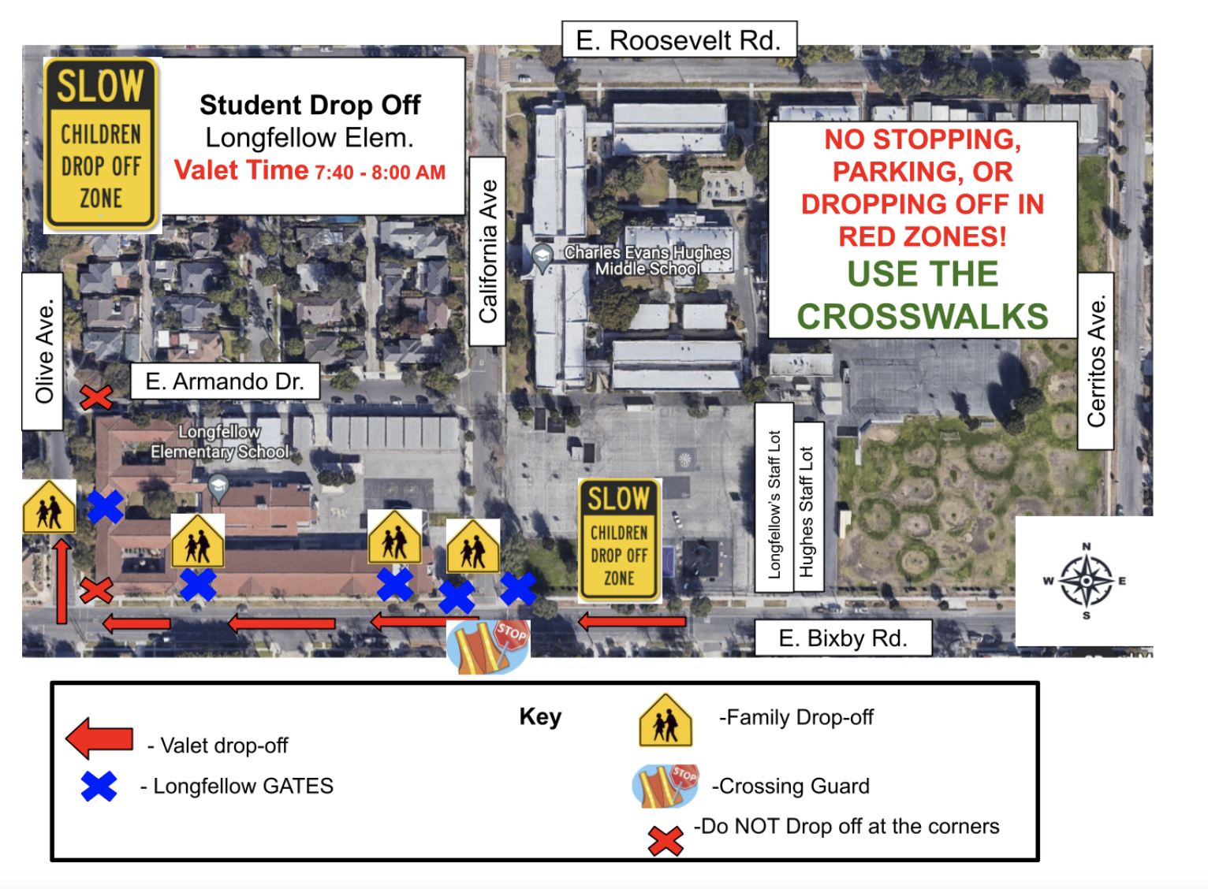

**STUDENTS KEPT AFTER SCHOOL**

On very rare occasions, students may need to stay after school for individual help, to finish work not completed during the assigned time in class, or for disciplinary reasons. If more than 15 minutes is needed, parents/guardians must be contacted by the teacher. *If your child is picked up by an after school program requiring transportation, please make sure to notify your child’s teacher. Not doing so may cause your child to miss their bus or daycare pick up.*

**TOBACCO-FREE SCHOOLS**

The Long Beach Unified School District is officially a smoke-free, tobacco-free district. Any tobacco use (smoking, chewing, etc.) by anyone is prohibited at any time on any LBUSD property. This requirement applies to all students, staff, school visitors and volunteers.

**USE OF THE OFFICE TELEPHONE**

With the large number of children at school we must limit calls to matters of a serious or emergency nature (*determined by the office*). Arrangements for pickup, after school care, etc. should be made each morning at home. Students are not allowed to call regarding these matters until after the playground closes at **3:00.**

**CELL PHONE USE / TEXTING POLICY**

If you feel your child needs to carry a cell phone to and from school for safety purposes, please go over these rules and consequences with your child throughout the school year.

**Cell phones are to be turned off and stored in the student’s backpack during school hours. At no time during school hours should a student have their cell phone on or out of their backpack for any reason.**

***There will be a designated area for students needing to call a parent or guardian after school. Students may make the call/text and put their phone away and return to play***. If a student is found to be in possession of a cell phone either making or receiving calls or texting or receiving texts or using it for any other purpose during school hours, the phone will be taken from the student and the **parent/guardian** will have to pick it up from the office.

Additionally, students may not visit social media sites, play games, music or take pictures with their cell phone while on campus. If a student is found to be doing so, they will be required to report to the office and a parent/guardian will be called to retrieve their cell phone.

Continuously ignoring these rules can result in the student losing the privilege of having the phone at school.

***Neither the school nor district is responsible for personal items lost or stolen, including cell phones.***

**UNIFORM POLICY**

The Long Beach Unified School District requires all students in TK through grade 8 to wear a school uniform. A copy of our Longfellow dress code is in this handbook. In cases of economic hardship, help in obtaining uniforms is available through the office or school nurse. You may obtain an exemption from the uniform requirement. For further information, call our office.

All of our students are actively involved in physical exercise and games during PE time and recess. For safety and for your child to be able to fully participate in all school activities, we ask that he/she wear shoes that are constructed for running and for exercising. Open-toed shoes, backless shoes, sandals, dressy or high-heeled shoes **may not be worn to school**. Tennis shoes are ideally suited for all school activities.

**Consequences for NOT wearing appropriate uniform apparel:**

1. *The student will be sent to the office to change into appropriate uniform apparel.*
2. *The classroom teacher will send a note home to remind parents/guardians of the policy*
3. *The classroom teacher calls home to conference with parents/guardians.*
4. *The classroom teacher sends the student to the office to meet with the counselor, nurse or principal.*

The LBUSD Dress Code applies to all students. Students in need of financial assistance obtaining uniforms are encouraged to contact our Office Supervisor, Counselor, or school Nurse.

**Head and Neck**

* + No neck scarves
  + No makeup
  + Hats – outside only

Approved sun hats (wide brim) or baseball-style OK

**Body**

Tops

* Solid white, navy blue or red – no trim
* Logo-free or Longfellow logos only
* Longfellow t-shirts and spirit wear

Bottoms

* Solid navy blue pants – long or short

Long pants – Solid navy blue capri or pedal pushers

Shorts – Solid navy blue mid-thigh to knee length

* Solid navy blue biking shorts, jeggings, or leggings – under skirts/dresses
* Solid navy blue skirts – no shorter than arm’s length or longer than 3 inches below the knee
* No more than 1 inch larger than waist
* **Dark** navy blue denim
* No **light denim**, sweats, or overalls
* No torn, frayed, holes, sequins or embroidery
* Should be at least as long as the fingertips will reach when student’s hands are at her/his/their side

Dresses

* Solid navy blue
* Solid red

Outerwear

* Sweaters or sweatshirts – Solid navy blue, red or white
* Logo no larger than the size of a hand on sweatshirts and jackets
* Rainy day gear and winter jackets not worn in the classroom, not required to be solid navy, red or white

**Feet**

Shoes – Appropriate for physical education

* Closed-toe and heel (no back straps)
* Flat soles – less than 1 inch
* No boots, slippers, “Heelys”, “Crocs,” “Uggs”, ballet slippers, sandals, or blinking shoes
* Rain boots may be worn on rainy days

Socks

* Must be worn
* Tights, footless tights, leggings – under skirts – white, navy blue or red

socks may be any color (below the knee)

**\*\* Picture day dress code: Fall pictures, students are to wear their uniform**

**Spring pictures, students may have free dress**

Note*: The District requires all students in TK through grade 8 to wear a school uniform as identified by the student’s school. In cases of economic hardship, help in obtaining uniforms is available through Rick-Rackers, Operation School Bell. You may contact Nurse Linda in our office, for assistance. You may obtain an exemption from the uniform requirement.

**The Green Team is committed to reducing waste and promoting sustainability by engaging students, families, and teachers.**

**There are ways to be Green both on and off campus!**

**Recycle and Reduce Waste:** There are blue recycling bins in the classrooms and purple city recycling bins around campus. Reduce waste by using both sides of paper and by bringing reusable items (like water bottles and lunch boxes) to school. New trash receptacles have also been placed outside campus for all non-recyclables.

**Food Recovery:** Students who don’t want/like part of their lunch can place it on the Share Table in the cafeteria. Students who are still hungry can take anything they want from the Share Table, keeping food out of the landfill.

**Walk to School Wednesdays:** Walk, bike, skate, or scooter to school on Wednesdays (and everyday)! Students can earn Green Deeds tickets for walking. Parents/guardians/caregivers can volunteer to assist as crossing guards. If you can’t walk, try to carpool or use public transit. Never idle near campus. Turn your car off while waiting to pick up students to reduce air pollution for everyone.

**Green Spaces on Campus:** Students can enjoy the school gardens in many ways. Green Team leads volunteer days to help with weeding and planting. Green Team also works to bring additional green spaces, trees, and other shade structures to campus. We’re excited to have Ground Education starting at our school in 2023, and will continue to assist them in any way we can.

**Trash Cleanups:** Join California Heights Neighborhood Association’s Clean Streets community project on the 4th Saturday of each month (some exceptions) to clean up trash around Longfellow and the surrounding neighborhoods. Encourage students to always keep campus clean. More information about the Clean Streets community project can be found at this link:<http://calheights.org/community-events/clean-streets/>

**Green Deeds:** Students can earn Green Deeds tickets through various green acts, like picking up trash, walking to school, helping in the garden, and more. Students can submit their Green Deeds tickets into Green Deeds drawing boxes around campus for a chance to earn prizes.

**Community Events:** The Green Team hopes to bring the community together as much as possible to celebrate being Green in person and through social media and digital events. Our Earth Month fair is our biggest community event.

Please email greenteam@lblongfellowpta.org or scan the QR code to get involved or for more information.

